**MATHEMATICS METHODS UNIT 1 TEST 1**

**CALCULATOR ASSUMED NAME: _____________________**

**TIME ALLOWED: 40 MINUTES 39 Marks**

***Show all your working clearly.*** *Your working should be in sufficient detail to allow your answers to be checked readily and for marks to be awarded for reasoning. Incorrect answers given without supporting reasoning cannot be allocated any marks. For any question or part question worth more than two marks, valid working or justification is required to receive full marks. If you repeat any question, ensure that you cancel the answer you do not wish to have marked.*

**QUESTION 8 (5 marks)**

Three towns Brooks River (B), Fryman Mill (M) and Swann Place (S) are to cultivate the triangular piece of land that they immediately surround. M is 2000m due South of B. S is on a bearing of  from B and  from M. Calculate the area of this piece of land (to the nearest m).

**QUESTION 9 ( 3,1 marks)**

The area of a sector AOB, in a circle centre O and radius 4 cm is  cm2. Find the size of :

(a) in radians in terms of π.

(b) in degrees

**QUESTION 10 (2, 3 marks)**

The lines y = - x – 3 and y = 3x + 5 intersect at point A.

1. Using your calculator, or otherwise, find the coordinates of point A .
2. Find the equation of the line that is parallel to 2y + x = 6 passing through point A.

**QUESTION 11 (2, 2, 3 marks)**

Given A ( 4, 3 ), B ( -2, 7 ) and C ( -4, -1 )

1. Find the equation of the line with gradient 3 passing through C.
2. Find the midpoint of AB
3. Find the equation of the line perpendicular to y + 4 x = 7 passing through B.

**QUESTION 12 (2, 3, 1, 2 marks)**

An arc of length 15cm in a circle with radius 8cm subtends an angle of θ at the centre.

1. Find the exact size of θ in radians.
2. Find the area of the sector.
3. A forgetful mathematics student once got mixed up and found the area of the above sector in a similar way to the area of a triangle ie. ½ (15) x8. Comment on this answer.
4. Show that the area of a sector with angle θ, radius *r* and arc length *l* is in fact (*rl*)/2

**QUESTION 13 (6 marks)**

An equilateral triangle of side length 9 cm has circles with centres at each of the vertices drawn to pass through the other two vertices. Find the area common to the three circles.

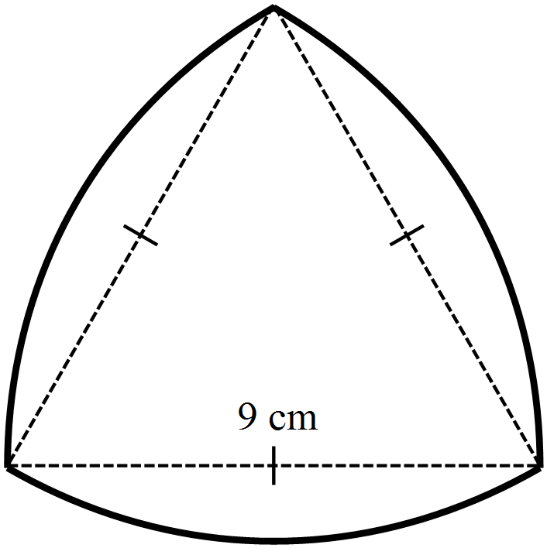

**QUESTION 14 (3,1 marks)**

The owner of a shop that sells computers calculates that his total weekly profit is given by the rule:

Total profit in dollars =,

where  is the profit per computer sold,  is the number of computers sold in the week and  is the fixed weekly cost of running the shop.

If he sells ten computers in a week his total profit is $360.

If he only sells five computers in the week he makes a loss of $190.

1. Calculate  and .
2. What is the least number of computers he can sell and still make a profit?